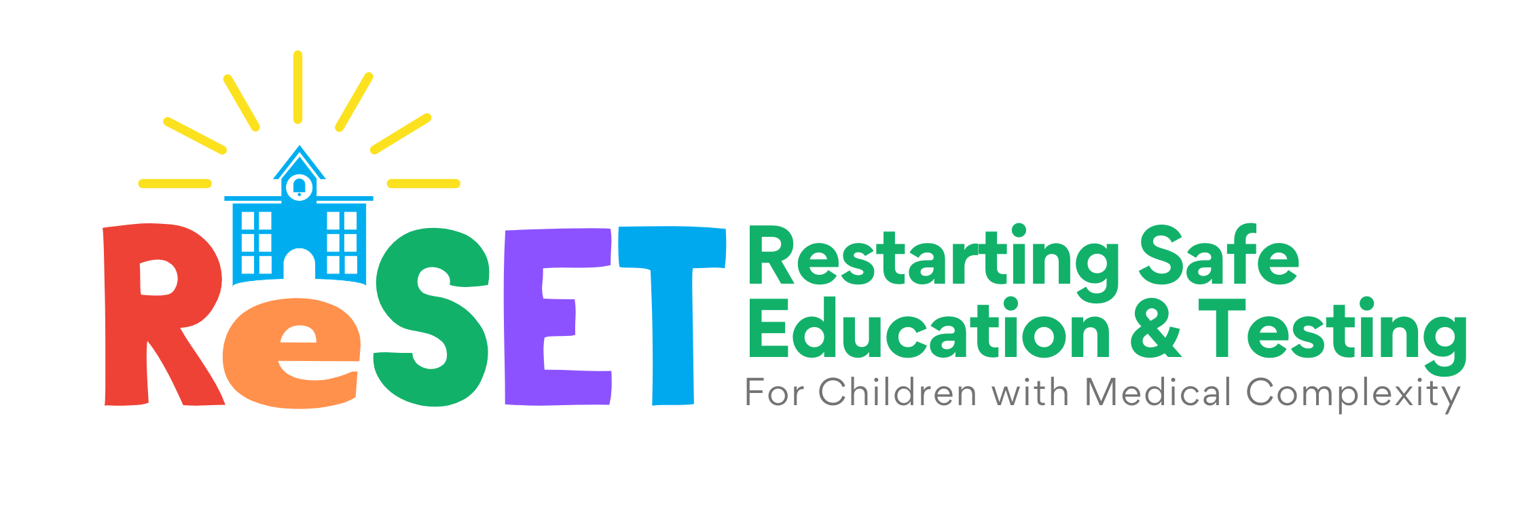

Family Decision-Making Tool
Updated March 2022

When illnesses like flu and COVID-19 are circulating in the community, having your child at school safely can feel difficult. This tool will help you make the best decisions for your child and family.

All final decisions about delivering special education will be made together with your child’s Individualized Education Program (IEP) team.

Contents
- Understand the health risks for your child 2
- Think about your child’s health and well-being at school 3
- Figure out the goals for your child and family 3
- Select strategies that help meet goals and limit risks 4
- Plan next steps. 7
- Gather more information. Decide when ready 8
- Notes 8

1. Understand the health risks for your child.

Think about the current risk of respiratory illnesses (flu, COVID-19) to your child and family.
- Discuss with your child’s health care team such things as prior COVID infection, vaccination status, your child’s specific medical conditions, and community transmission.
- Remember that risks are lowest if your child is fully vaccinated and can use recommended safety measures such as masking, distancing, handwashing, protective equipment, and testing.
- Ask your child’s teachers, primary care provider, and health care team about their concerns for your child attending in-person school.
- The school nurse can also assist with this step.
What are your thoughts and concerns about your child’s current risk overall?

Think about your child’s school day and activities, from start to finish.
Which activities are you most concerned about? Choose the activities you have questions about or would like to focus on to ensure your child’s health and well-being while at school. You might consider the number of people, duration of the activity, physical distancing, and the ability of students and staff to mask during these times.

Transportation to and from school
Breakfast/Lunch
Classes (Full group)
Classes (Small group)
Physical Education class
Music class
Hallways and passing time
Therapy and individual services
Recess and Outdoor Time
Extracurricular Activities (including before/after school)
Other:

2. Think about your child’s health and well-being at school.

Think about your child’s school and its strategies around COVID-19?

- These
strategies
may include
communicating
with families,
masking,
vaccination, physical
distancing, hand
washing, protective
equipment,
education for
families and
students about
infection prevention
and the risks of

respiratory illnesses,
and
COVID-19 testing.

What strategies is your child’s school using to keep your child and other students healthy while at school?

What individual protections or accommodations can your school provide your child?

3. Figure out the goals for your child and family.

- Consider your child’s educational,
social/emotional, and health- related goals.
What are the most important reasons for your child to be at school?

What are your concerns if your child is not receiving instruction in person at school?

4. Select strategies that help meet goals and limit risks.

Think creatively about ways to meet these goals and lower these risks while at school.

Think about the times and situations you are most concerned about, such as the ones you picked in section 2. Consider successful strategies other families and schools are using during those activities to enhance safety and in-person learning.

Here are some examples:

Set Priorities for Classes and Activities
Are there specific classes, therapies, or other more essential experiences than others? Could being at school be limited to those activities?

Possible Strategies:

a | Child’s in-person classes and group activities use physical distancing when possible. Allowing for six feet of distance from classmates during priority classes and activities can limit the risk of exposure.
b | Child’s classes and group activities are “cohorted” when possible. This keeps close interactions to a “cohort,” or small group, in order to limit the risk of exposure.
c | Encourage and support your child to advocate for themselves when distancing, cohorting or other health and safety strategies are not possible. Think about simple phrases or hand gestures they can practice and use to communicate their preferences for distancing and other safety needs to classmates and teachers.

Adult Support
Are people interacting with your child as safe as possible, such as wearing masks and protective equipment when recommended, using safe distances, and hand hygiene? If not, could they?

Possible Strategies:

a | Adult staff interacting directly with your child agree/are required to wear masks (This includes the teacher, aides, bus driver, “specials” teachers like PE and music, and mealtime supervisors.)
b | Adult staff interacting directly with your child agree/are required to be vaccinated.

School Day Schedule Adjustments
If your child cannot wear a mask for an extended time, could their in-person school day be limited to the period they can tolerate?

Possible Strategies:

a | Ask if therapy or other individual services at school can be scheduled for after school or other times when there are less people in the building.
b | Allow child to have different passing time in hallways to limit exposure to crowds.

Safe Spaces
Are there places in school where your child is less likely to be exposed to viruses? Are there times of the day that your child can spend time in these spaces?

Possible Strategies:

a | Use outdoor spaces for physical education, mealtimes, and classes whenever possible.
b | Use classroom or “pod” space for mealtimes.
c | Have a cart deliver lunch to classrooms or pods instead of having children travel or eat in the cafeteria.

In School or Not
Would it make sense for your child to attend only part-time or arrange for school in another location (home, smaller private school, etc.)?

Possible Strategies:

a | Ask the school which classes and services are available only in-person and which are able to be offered or adapted for at home or virtual instruction. This will help you understand your options for a hybrid schedule.
b | Use a hybrid schedule to allow the child to attend priority classes and services in- person for partial days (ex. AM or PM only) or weeks (2-3 days), continuing with virtual instruction from home for other classes and services.

Transportation, Before and After School
How is your child getting to and from school? Are they in programs before or after school? Do adjustments need to be made to these options?

Possible Strategies:

a | Transport your child privately/on your own instead of the bus. We encourage schools to reimburse families for this expense if possible.
b | Assigned bus seating can help to minimize exposure and offer distancing.
c | Avoid congestion during drop off and pick up times by choosing a low-traffic time and place for entry and exit into the building.

Changes to the IEP or 504 Plans
To maintain your child’s health and safety, are there any changes that need to be made to their IEP or 504 plans? Are there times of the day that they need more adult help to navigate spaces to maintain their health?

Possible strategy:

a | Ask your child’s school or IEP team for a check-in meeting to share any health or safety-related questions or concerns about their IEP or 504 plan.

Input from School
Do your child’s teachers, aides, nurses, therapists, or others have suggestions about how your child can attend school safely?

Possible Strategies:

a | Consult with your child’s school and adult support staff to learn about and understand the options available to your child during specific times of day or activities for which you have a concern.
b | Ask the school and school nurse to stay in communication with your family about potential exposures and cases at the school so you can make informed decisions about your child attending in-person.

Making and Updating Your Plan
Based on how things go, could you start with one plan now and make changes in 1-2 months?

Possible strategy

a | Use a slow and steady approach to start. Think about how your student’s plan may progress to include a greater number of in-person classes, days, or services over time as comfort increases .

Choose strategies for you and your child’s school to pursue to maximize in-person learning experiences and ensure safety during their school day. List them here.

Strategy 1
Strategy 2
Strategy 3

5. Plan next steps.
Identify action steps and questions for the strategies you’ve chosen.
Next Step or Question for Follow-Up

People/Resources to Contact

6. Gather more information. Decide when ready.
Once you’ve completed this document, take a look through it. What stands out to you? What would you like to follow up on? What seems like a good starting place?

After you reflect, it’s time to share the results with your trusted support people—including teachers, primary clinicians, therapists, specialists, other families, etc. You may consider how this information could be used to inform your child’s IEP or 504 plan.

Gather more information from your trusted support people and other sources as needed to help you—when you’re ready—make the right choices for your child and for your family.

Learn more and stay in touch with us at reset4kids.org.
Notes:

